Conventional MIMO detection technology
Based on ML(maximum likelihood)
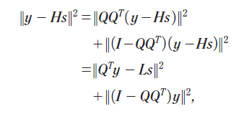
1. Zero forcing(ZF): travel the entire tree to find the smallest cumulative metic however costly
2. Zero forcing decision feedback(ZFDF): low cost, make use of the previous data, but it has error propagation.
3. Sphere decoding(SD): first selects a user parameter R, called the sphere radius. It then traverses the entire tree (from left to right, say). However, once it encounters a node with cumulative metric larger than R, then it does not follow down any branch from this node.
it can be improved use pruning. Set an M which is flexible, the distance of one of the elements in equation 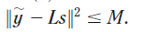
- Fixed complexity sphere decoding(FCSD): begin from the layer r, and then use ZF or ZFDF.
- Semidefinite relaxation detector(SDR): the algorithm to minimize 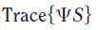
- Lattice reduction aided method: project the original constellation to a lattice then find a well conditional matrix 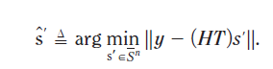
Then after get 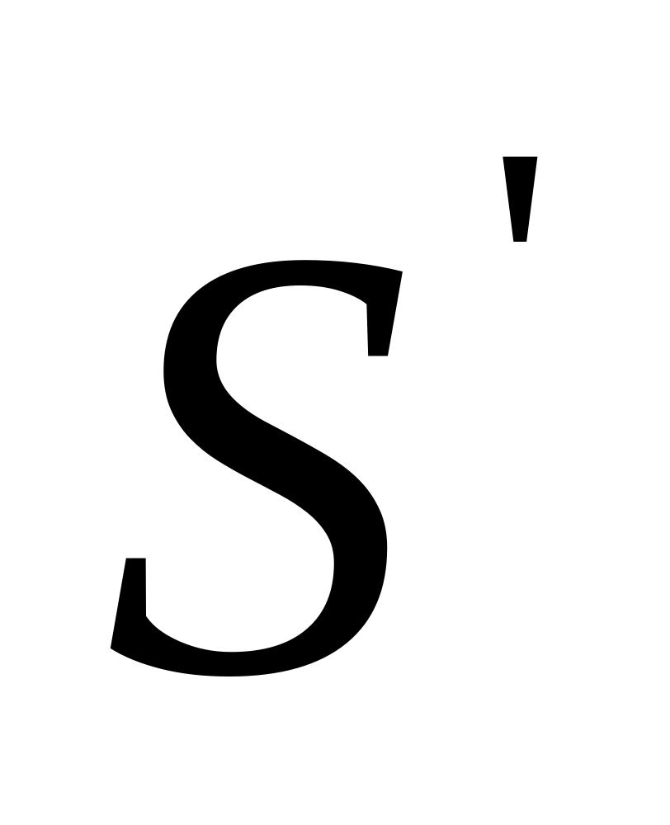 just form back to
The LR method has two crucial steps 1. Get the matrix T 2. What we get is the solution  always belongs to , it may not belong to . Namely, some of its elements may be beyond the borders of the original constellation. Hence a clipping-type operation is necessary and this will introduce some loss.
- Soft decision

Conclusion
[1] E. G. Larsson, "MIMO detection methods: How they work [lecture notes]," Signal Processing Magazine, IEEE, vol. 26, pp. 91-95, 2009.

